Notes - The Civil War

The Last Straw

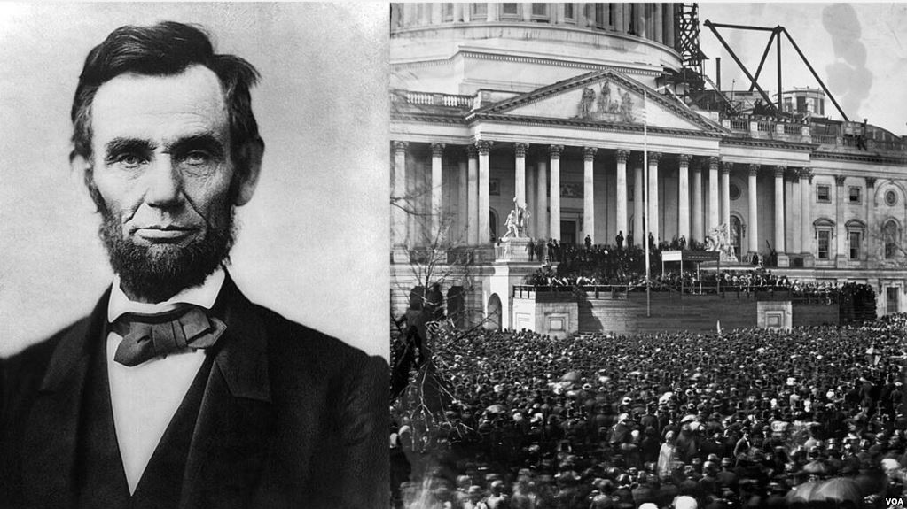
Southerners (many states at least) promised that if Lincoln was elected in 1860, that event would be the “last straw” or the final motivation to secede from the Union.

Secede – to formally declare independence from the U.S., to leave the Union.

Lincoln Intends to Keep the Union Together

Lincoln no doubt was determined to keep the Union together. He stated in his Inaugural Address that he would not mess with slavery as it existed, BUT the Southern states could not just leave the U.S. and they could not seize (take over) federal government property just because it was located in their states.

Fort Sumter, South Carolina

In 1861, South Carolina urged U.S. military troops to abandon a U.S. military fort called Ft. Sumter because it was located in South Carolina’s territory. South Carolina was the first state to secede or declare independence from the U.S.

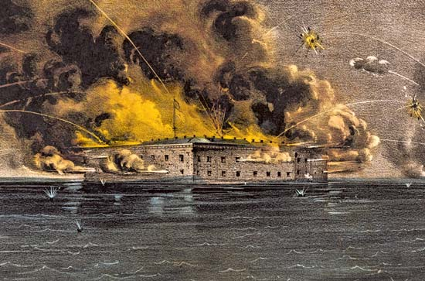
After the U.S. refused to leave their post, and thinking the fort was being re-supplied for battle Confederate troops bombarded (attacked) Ft. Sumter. The fort was important to South Carolina because it controlled the entrance to Charleston Harbor, which was a major trading destination for the South. The Civil War had started. This is the first battle of the war and the Confederacy won.

Lincoln Reacts to Ft. Sumter

Lincoln asked for thousands of troops to put the rebellion to a halt. States now had to choose sides. Do they secede or do they stay with the Union and fight the rebels? North Carolina, Tennessee, Virginia, and Arkansas seceded. States north of those such as Pennsylvania and New Jersey sided with the Union.

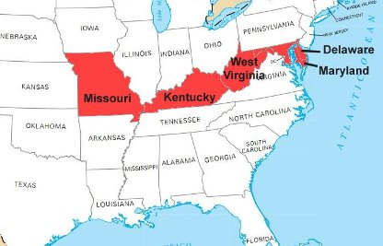
Border States

Delaware, Kentucky, Maryland, and Missouri were right in the middle of the seceding states and the Union states. Lincoln sent federal troops to those border-states to keep them a part of the Union.

Northern Advantage

The North had control of a large amount of canals, rivers, and railroads. They also had a huge population base to use during the war. The South, had much less population and only some rivers and railroads for their needs. Northern General Winfield Scott proposed a blockade of the Confederate ports, taking control of the Mississippi River, and quick and decisive attacks on Richmond, Virginia, which was the Confederate Capitol.

Southern Advantage

Although heavily outnumbered, the Confederates had very strong leaders such as Robert E. Lee (commander of the Confederacy), General Thomas “Stonewall” Jackson, General John Bell Hood, and General James Longstreet, just to name a few. The South, also, only needed to defend its territory, not attack the Union. The Union needed to attack and control the South in order to stop the rebellion. This was a huge advantage of the South because the Confederacy knew their territory very well. Much of it was wilderness and farmland. Many of the rivers ran east and west as well which provided barriers from the attacking North.

Jefferson Davis – President of the Confederate States of America

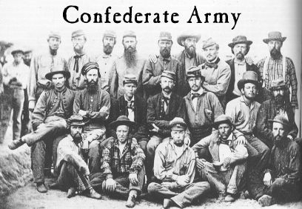
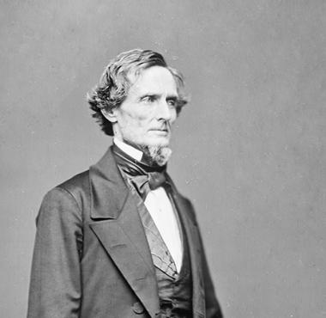
Jefferson Davis was appointed the President of the Confederacy. He was a former high-ranking U.S. congressman and a Mississippian. He, along with others believed Great Britain would support the Confederacy in their efforts to remain independent because of the South’s high volume of cotton production needed in Britain’s textile industry.

No Military Training

Many on both sides were very experienced in war. Regular men: teachers, farmers, doctors, factory workers, skilled-laborers, all of them were inexperienced soldiers. They had to learn quickly how to march, shoot, and use their bayonets (knifes attached to ends of rifles.) Many of the soldiers on both sides wore their regular clothing from home. Eventually, as they were produced, the Union Army would wear navy blue and the Confederate Army would wear gray.

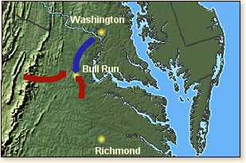
Battle of Bull Run/Manassas

First, many of the battles in the Civil War have two names. This is because the Union would generally name a battle based on a local landmark such as a river or creek. The Confederates would name a battle based on the location nearby such as a town or city. So, the Union called the Battle of Bull Run this name because of the local creek nearby called Bull Run. The Confederacy called the same battle Manassas because of the city it was nearby called Manassas, Virginia

The Confederacy was quickly gifted with a good surprise in leadership. General Thomas Jackson was seen leading his troops in battle against the Union when a Confederate soldier yelled out “There is Jackson standing like a stone wall…rally behind the Virginians.” This is how Jackson got his nickname “Stonewall Jackson.” He was often seen in the middle of battle unafraid leading his Virginia soldiers.

The Confederacy won this battle. It quickly ended the idea that the Civil War would a short one for the Union.

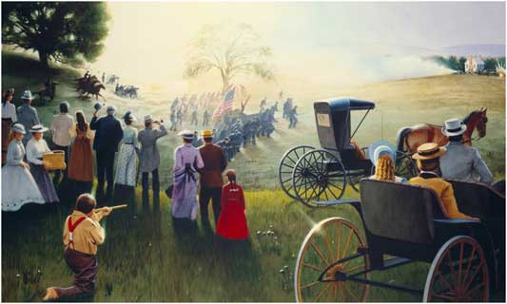
Picnics in the Park

Many citizens believed this “rebellion” of the Confederate States would end swiftly and the Union would come out on top. They would set up picnics overlooking the Battle of Bull Run/Manassas, unprepared for the bloodshed that would come. The reality of war had set in for both sides.

General George B. McClellan Take Command
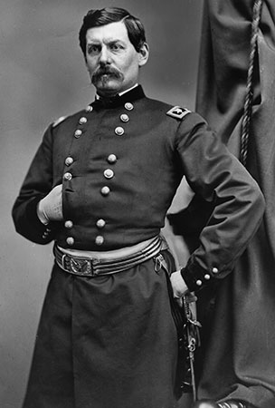
General McClellan took command of the Union Army. It was called the Army of the Potomac (a river in Virginia that famously is in the backyard of George Washington’s Virginia Plantation at Mt. Vernon).

Stonewall Jackson tried to push towards Washington, D.C. and capture the U.S. Capitol, but was stopped. However, General McClellan could not be resupplied.

Robert E. Lee – Seven Days’ Battles

Lee and his troops forced seven days of battles forcing the Union out of the capitol city of the Confederacy of Richmond, Virginia. These were bloody battles that was describes as vicious and murderous. The Union had to retreat. (On a side note, Richmond and Washington, D.C. were very close to each other, so that means the Union and Confederate capitols were within easy reach of each other.)

General George B. McClellan
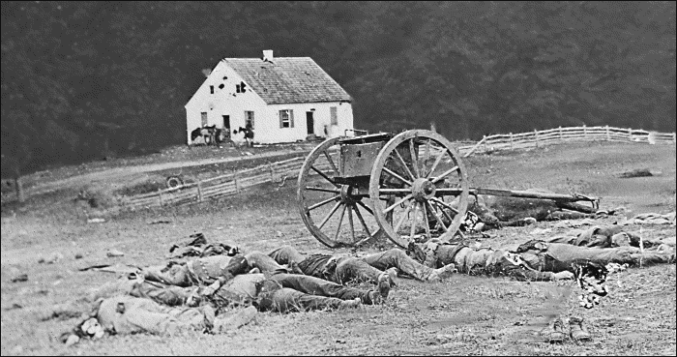
Battle of Antietam/Sharpsburg

Antietam was the creek nearby. Remember the how the Union and Confederacy named the battles? Antietam was in Maryland, and on September 17, 1862 fighting began and ended at the Battle of Antietam. The Union suffered 12,000 casualties while the Confederacy suffered 13,000 casualties. It is known as the “single bloodiest day (or battle) of the war, and in U.S. history.”

The Union won.

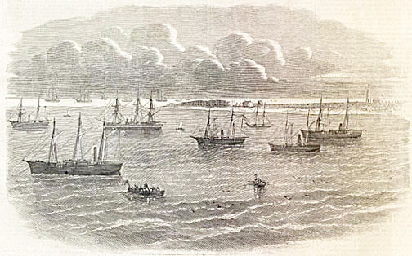
Blockade of Southern Ports

The Union set up blockades of the Confederate ports to halt their resupply and trade. This was done in order to help ruin their economy.

Ironclads

The Confederacy began building warships out of iron to stop the blockades from causing damage to their ships. The British did not stop these ships from being delivered to the South, which created a problem because they were supposed to remain neutral.

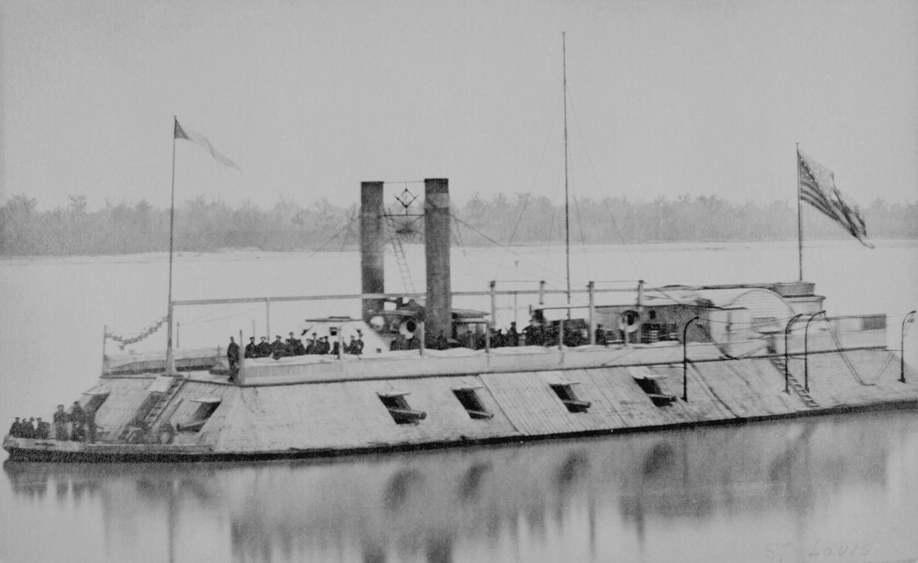
This new idea changed the way naval ships would be built in the future.

Battle of Shiloh

General Ulysses S. Grant was leading Union troops in the western part of the war. The Confederates attacked Grants troops at Shiloh, in Tennessee. The Union would ultimately win and gain more control over the Mississippi, BUT NOT FULL CONTROL.

Battle of Vicksburg, Mississippi

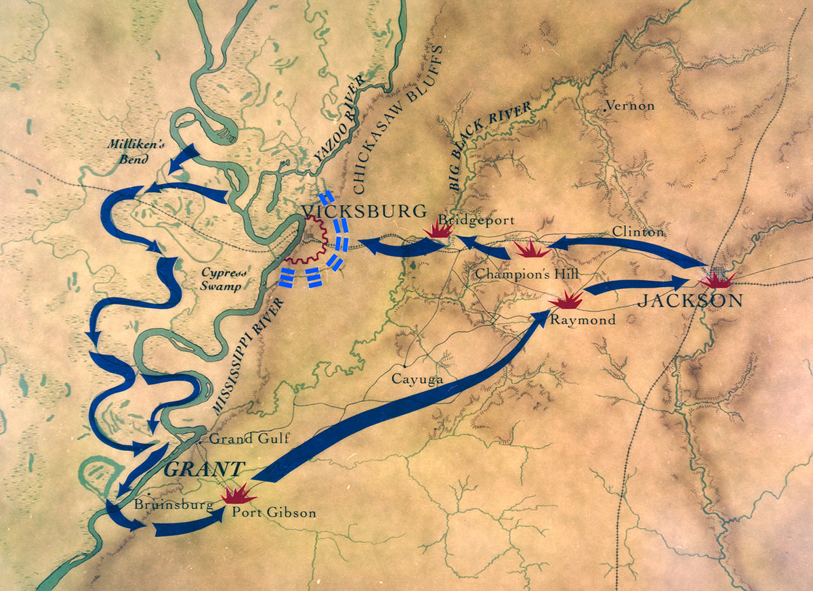
General Grant decided the Union needed to control the Mississippi once and for all. It was a very high city above the Mississippi River located on cliffs above. General Grant cut off supplies to the city hoping to get the Confederacy to surrender. He began the Siege of Vicksburg in May of 1863. In July, the Confederacy finally surrendered to Union General Grant. The North now controlled the Mississippi River.

Emancipation Proclamation

Lincoln struggled with this idea. Finally he issued the Emancipation Proclamation to free the slaves controlled in Confederate territories. His design was to help cripple the Southern economy and cause chaos as slaves were leaving. He also tried to recruit these former slaves to join the Union cause.

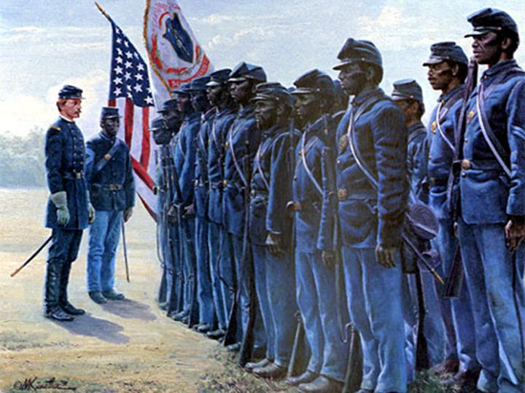
54th Massachusetts Infantry

This unit of Union soldiers consisted mostly of African Americans that were free. In 1863 they led a heroic charge on Fort Wagner in South Carolina. This unit is depicted in the Academy Award winning film in 1989 titled “Glory” staring Denzel Washington, Morgan Freeman, and Matthew Broderick.

Many African Americans were convinced that if they fought for the Union, they would be given rights upon their completion of service if the Union won the war.

Copperheads

These were people living in the Midwest (think Ohio River Valley) that believed the war was unnecessary and should end. They were mostly against abolition and had sympathy for the South.

Lincoln, fearing their influence suspended the right of Habeas Corpus (protection from unlawful imprisonment) and began imprisoning Copperheads without trial. This action was met with anger by Democrats and some Republicans.

Battle of Fredericksburg/Chancellorsville

Fredericksburg was in Virginia. The Union Commanding General, Ambrose Burnside could not break the Southern line to take over Fredericksburg. He led several attacks on Robert E. Lee’s Confederate forces but retreated after heavy casualties. He resigned as Union general.

General Joseph Hooker took over as the leading Commanding General of Union Forces (Army of the Potomac.) He tried to take on Lee’s forces from the front, but could not succeed for some reason.

Lee ordered an attack on General Hooker’s troops at Chancellorsville, Virginia (west of Fredericksburg) and won. This was a huge victory for the Confederacy, but the Confederacy suffered a heavy tragedy.
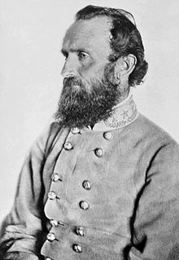
General Stonewall Jackson
Stonewall Jackson Dies

During the Battle of Chancellorsville, Confederate General Thomas “Stonewall” Jackson was accidentally shot in the night hours by one of his men who was surprised. He had to have one of his arms amputated, but several days later, he died of infection from his wounds.

Stonewall Jackson was a HEAVY loss to the South. He was very trusted and considered one of the most skilled and prized commanders of all of the Confederate Army as well as a motivator of troops. His soldiers always had confidence when Jackson was leading them in battle. They fought very hard for him.

Battle of Gettysburg – Turning Point

This was considered the “turning point” of the Civil War. Lee knew he had to make a splash because the Confederate Army was losing much of its soldiers and they needed to end the war. Against advice from his trusted generals, Robert E. Lee ran into Union General George Meade’s cavalry causing the beginning of the Battle of Gettysburg.

Pickett’s Charge

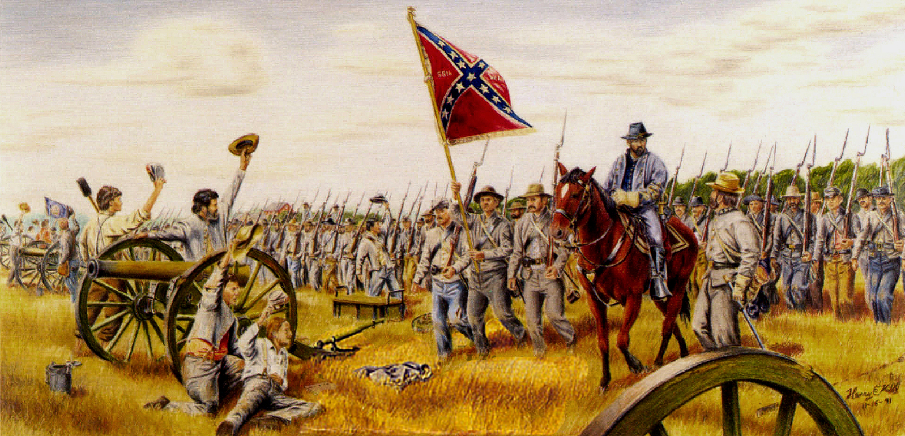
On day three, General James Longstreet of the Confederacy tried to convince General Lee not to attack the Union. Lee however disagreed and ordered Confederate General George Pickett to charge (march fast/run) the center of the Union Army, which was located high above on Cemetery Ridge. Lee thought the Union were about to break. He was very wrong.

General Pickett took 15,000 men and charged for 1-mile through wide-open fields (easily in view of the Union). The Confederates retreated after the Union pounded them with heavy artillery and gunfire. 7,500 men died. Lee took the blame for this mistake.

Gettysburg was the largest and bloodiest battle of the war. More than 50,000 soldiers were killed or wounded in this four-day battle. After the loss at Gettysburg, France and Great Britain would no longer help the Confederacy, fearing they were going to lose.

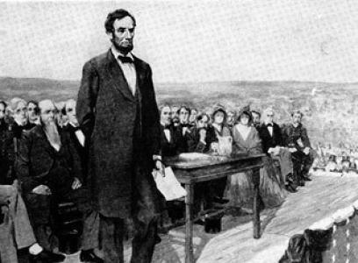
Gettysburg Address

On November 19, 1863, Lincoln gave a short speech dedicating the battlefield where so many Union soldiers had fought so bravely and died. He was committed to winning the war.

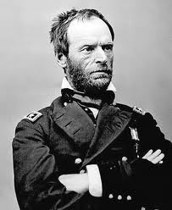
Sherman’s March to the Sea (Attack of the South)

Union General William Tecumseh Sherman was ruthless. Sherman marched his troops towards Atlanta, Georgia burning and destroying everything in his path. He murdered livestock, burnt homes, fields, property, etc. His troops destroyed everything it touched. This was designed to totally cripple the Confederacy.

Losing Atlanta meant the South would lose an important trade hub and an important railroad. His goal was to march all the way to the ports at the Atlantic Ocean in Savannah, Georgia.

Lincoln Wins in 1864

Lincoln won by a landslide (almost total unanimous victory) probably because the voters in the U.S. saw him as successful in the war.

Surrender of the South

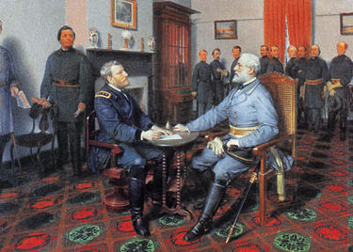
General Robert Edward Lee, Commanding General of all Confederate Army forces finally knew his army could not last any longer and there were no longer hopes of winning for the Confederacy. Lee knew there was no hope. He said, “There is nothing left for me to do but go and see General Grant…”

On April 9, 1865, General Robert E. Lee surrendered the Confederate Army to Commanding General of the Union forces General Ulysses S. Grant at Appomattox Courthouse, Virginia, ending the Civil War.

Effects of the War (Outcome)
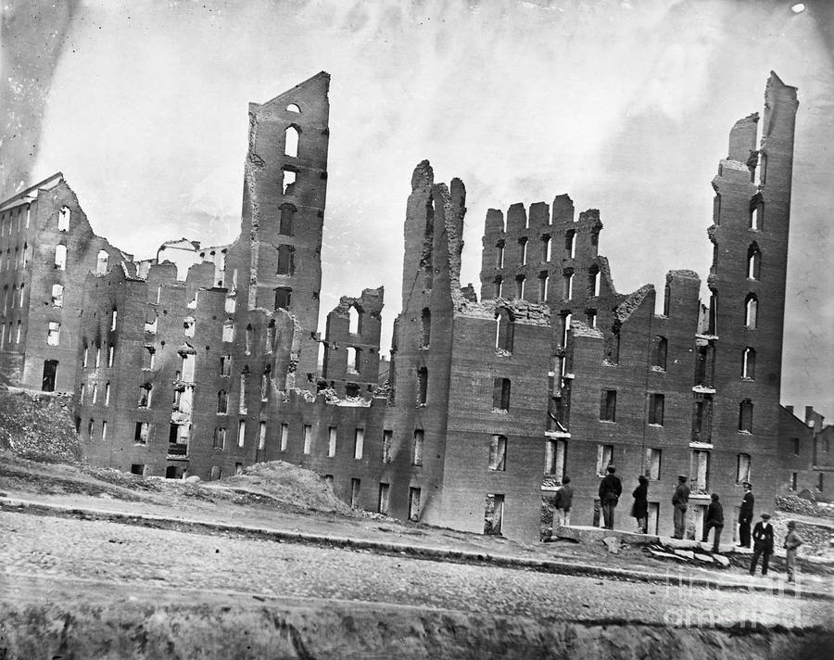
From 1861-1865, the U.S. saw the most bloody and heavy loss of life than any war in its history. There were more people killed during the U.S. Civil War than during all wars combined in the history of the United States.

Southern slavery was gone. The Southern economy was crippled. Much of the property to include cities, towns, homes, businesses, and livestock were destroyed. The South was virtually broke and homeless.

There were still severe hostilities between the North and the South. No one knew how they would every rebuild and repair the relationship, which destroyed so much and took so much life away.

