Notes - Reconstruction of the U.S. After the Civil War 1865 – 1877
What does it mean to reconstruct something?
To reconstruct means to rebuild or to put together again, in a general sense. When the U.S. Civil War ended, the U.S. had to find a way to rebuild not only the physical structures in the U.S., but also the relationships that were damaged during the war.

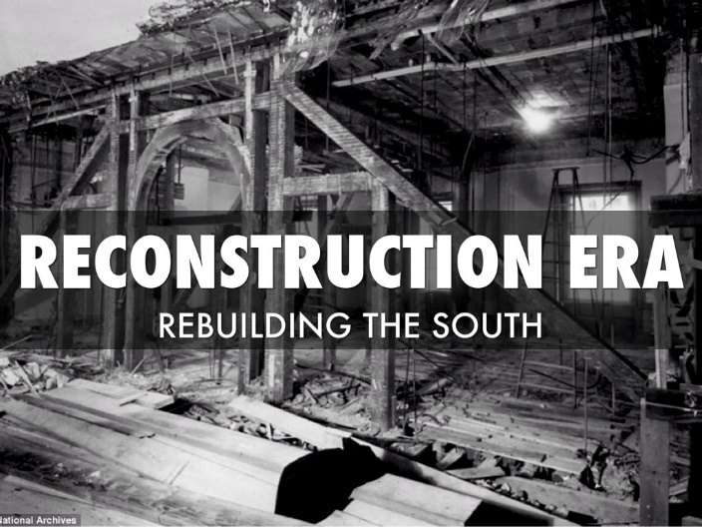
After the Civil War (Reconstruction)
The time period after the Civil War from 1865-1877 was called the Reconstruction period. What are we rebuilding?
- Relationships – there are many hostilities and dislike between the northerners and southerners still, even after the war, lots of distrust
- Property (physically damaged South) – most of the major battles and destruction happened on southern land and there was virtually nothing left undamaged by war
- Economy – generally speaking, the South was broke and the economy was in the “tank”

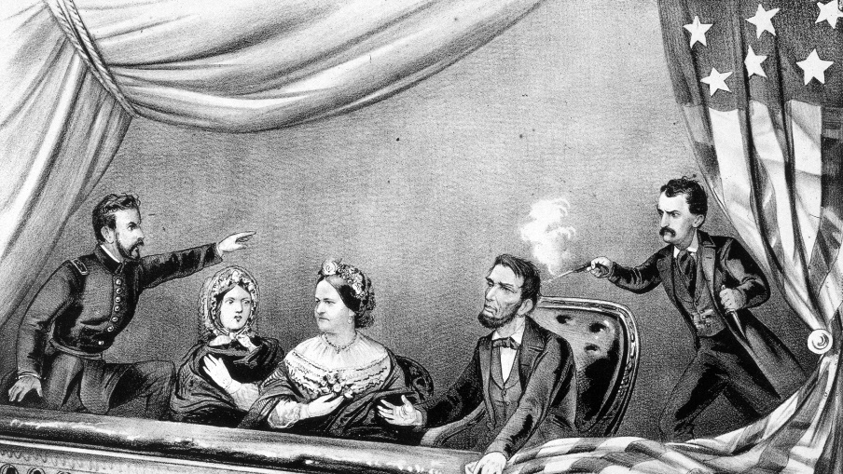
Lincoln Assassinated
Five days after Appomattox surrender, Lincoln is shot in the head and died of his wounds, by John Wilkes Booth, a southern sympathizer and actor. Lincoln was shot at Ford’s Theater in Washington, D.C.

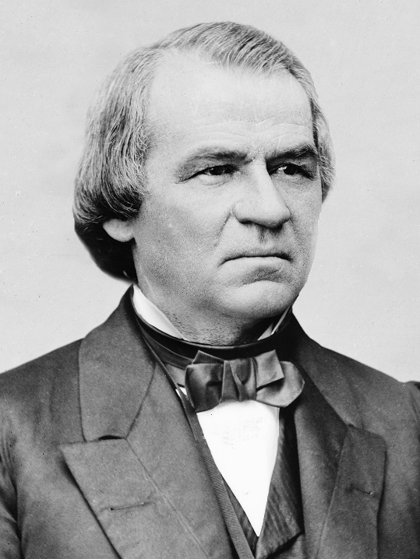

Johnson Becomes 17th President
Andrew Johnson, the Vice-President of Lincoln takes over after Lincoln’s assassination. He is a Democrat, where Lincoln was a Republican. He sympathizes with the South.

Lincoln’s Reconstruction Plan
Lincoln believed in forgiveness. He created the “10 percent rule.” What this means is 10 percent of the voting population in each seceded state that wanted to rejoin the U.S. had to swear and declare an oath the United States once again.
Moderate Republicans accepted this idea as a good thing to help rebuild the country faster.
Radical Republicans (who only want to punish the South and make them pay for the war) believe this is way too lenient (easy) and they wanted to make the rule 50% of the voting base swearing allegiance to the U.S.
Lincoln’s Qualifications for Seceded States to Rejoin the Union
- 10% of each state’s voting base had to agree to swear allegiance to the Union again
- Each state that seceded had to ratify the 13th Amendment which freed the slaves
- Each former state’s Confederate Constitution had to be scrapped and a new state constitution had to be drafted and approved

Radical Republicans in Congress
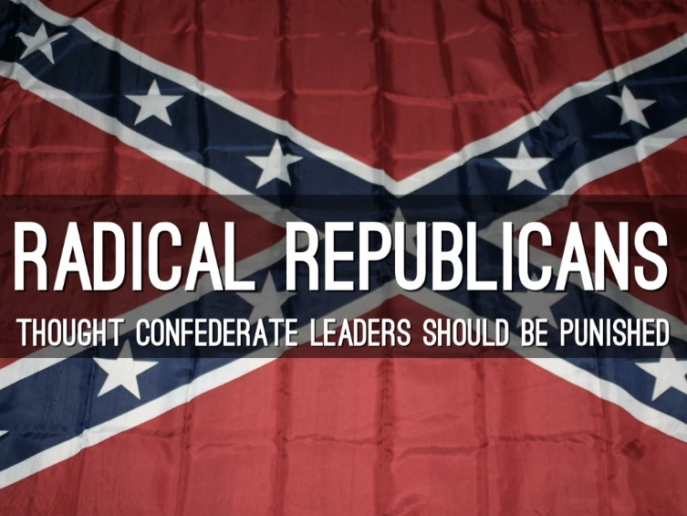
Radical Republicans are a smaller set of Lincoln’s party who believed that the South should be punished for causing the war. They did not want to pardon (free from guilt) the former Confederates like Lincoln and Andrew Johnson did.
They believed in heavy punishment, while holding leaders responsible, and wanted many tried for treason.
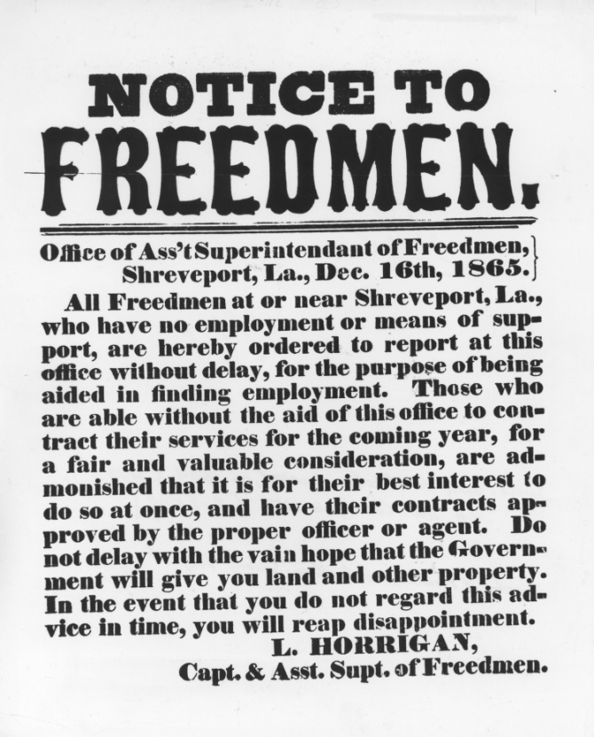
Radical Republicans will eventually dislike Andrew Johnson (17th President) that they will impeach him (basically for not behaving like they thought he should). Andrew Johnson will survive being removed from office by 1 vote.

Freedmen’s Bureau
A governmental organization designed to integrate and acclimate former slaves and blacks into American society. Many of these former slaves had zero education, no reading or writing skills, owned nothing, and had no job skills outside of what they did on plantations before the war.
The Freedmen’s Bureau was also designed specifically to educate the former slaves and blacks after the war. President Andrew Johnson did not like the Freedmen’s Bureau and did not renew its charter.
The bureau also assisted in splitting up much of the land in the South to give to former slaves to live and work on with the option of buying. Many southerners believed this was harmful to their way of life and that the U.S. sought to take their property away and reorganize their culture. It was met with heavy resistance.

Reconstruction Amendments
13th Amendment – An amendment to free all the slaves permanently and legally throughout all U.S. territory
14th Amendment – An amendment that gave citizenship to free blacks and former slaves
15th Amendment – An amendment that gave black men suffrage
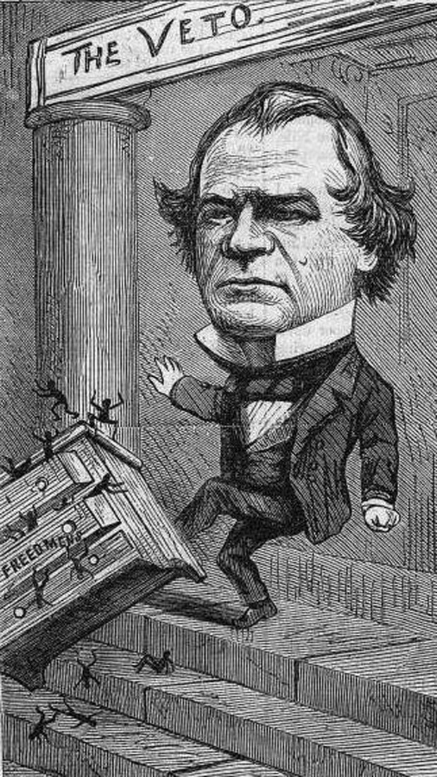
These amendments were designed to give blacks civil rights throughout the U.S. Radical Republicans supported these amendments while President Andrew Johnson completely opposed attempts to give blacks civil rights.

Reactions of President Johnson to Equality for Former Slaves
President Johnson did everything in his power to discourage equality for former slaves and blacks. He believed that the states should have more authority over themselves than that of the federal government. He did not renew the charter for the Freedmen’s Bureau. He opposed the civil rights of blacks and the Radical Republicans’ attempts to destroy the plantation lifestyle and destroy southern culture. He blocked every attempt at new legislation (laws) to help former slaves and blacks that he could. This made the Radical Republicans furious.

Johnson’s Impeachment by the Radical Republicans
Andrew Johnson became President with Lincoln’s Secretary of War Edward M. Stanton still in office. Stanton was a influential and hardcore Radical Republican. Johnson had many issues with the Radical Republican and their policies of pure punishment during the Reconstruction period.
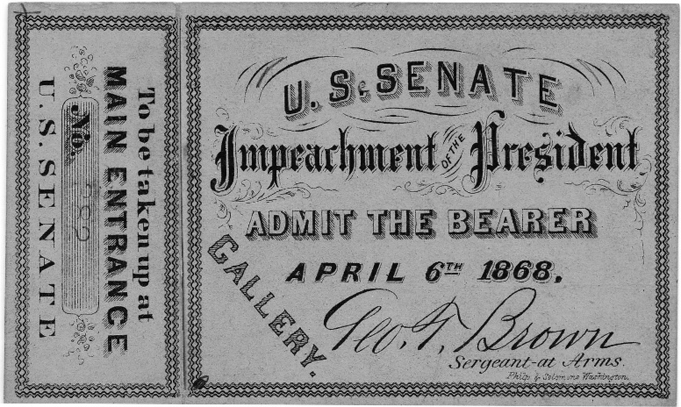
Radical Republicans passed a law (Tenure of Office Act) that said Johnson had to get permission from the Senate to replace cabinet members. He let Stanton go without permission and Radical Republicans began impeachment proceedings against him.
He was eventually found not guilty of crimes and not removed from office as President.

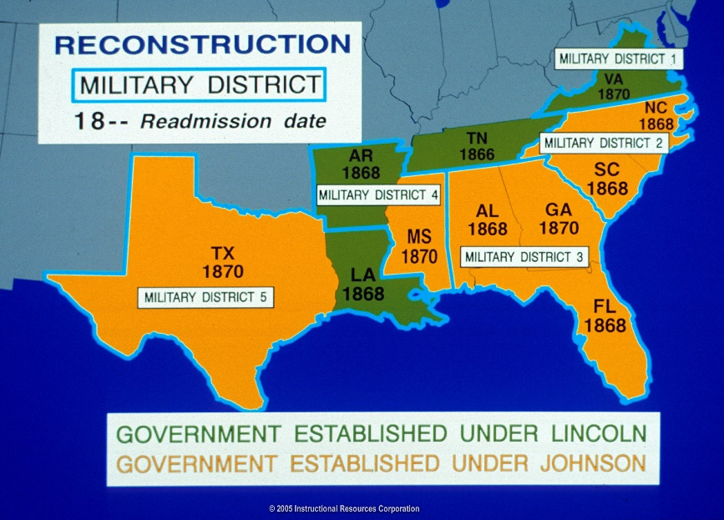
Martial Law in the South
Much of the South was put under martial law, or controlled by the military, and divided into military districts controlled by a Union General. This of course angered many in the South because they believed they were nothing more than conquered territory and totally at the mercy of the Union. They had curfews and Union troops were dispersed all over to protect freedmen. It was a humiliating time for the former Confederates.

Carpetbaggers and Scalawags
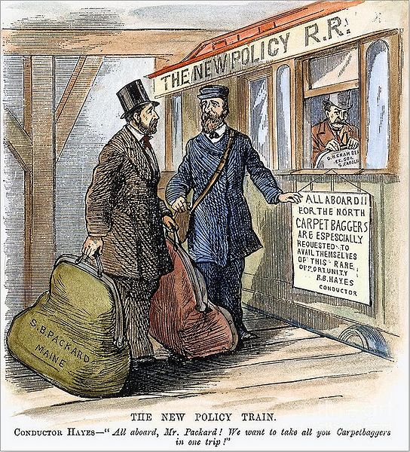
Many Northerners moved to the South hoping to take advantage of the misfortunes of the South during Reconstruction. These people were called carpetbaggers because they usually carried all of their stuff in a carpet bag.
Many Southerners who sided with the Union during the war also moved to the South all over and tried to take advantage of the situation as well. They all wanted to make their fortunes greater at the expense of the formers Confederacy.
Since former Confederates could not serve in any elected office during this time, carpetbaggers and scalawags held many elected offices throughout the South

Black Codes in the South
Many southern states passed state laws to effectively keep former slaves and blacks from having any form of civil rights. Some states passed laws much harsher than others. Some examples of these laws include:
- No interracial marriages
- No unemployment
- Curfews
- No serving on juries and testifying against whites
- No inter-mixing (segregation) of races
- Forced unpaid apprenticeships for children
- Forced some into chain gangs
- Forcing some to sign contracts to work for nearly nothing
- Outlawed freedom of speech

The Ku Klux Klan
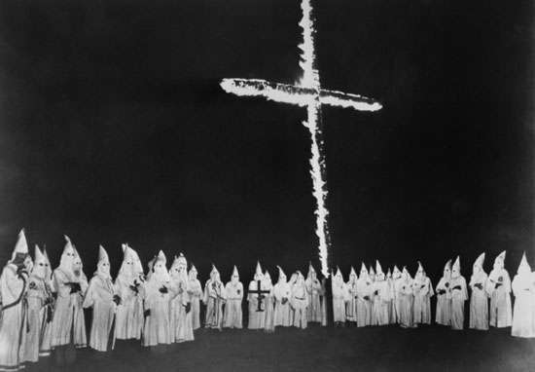
A group of former Confederates and white-supremacists formed an organization in Tennessee in 1866. It got its name from the Greek word “kyklos” meaning circle, and the ancient “often European” word “klan” meaning clan or family.
They terrorized freedmen and blacks all over, threatening and often using violence to keep them from exercising their civil rights and voting rights. They organized lynchings, beatings, and mob-riots as a means of terror and warnings to the former slaves and blacks. Their strong influence lasted well into the 1960s.

Sharecropping
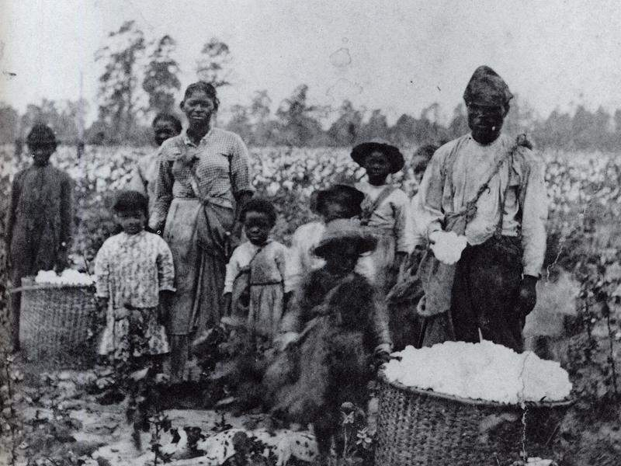
Many freed slaves had no job skills outside of the plantation. They couldn’t be slaves because of the 13th Amendment outlawing forced work, but they still needed to work. Many freed slaves went back to their former plantations and masters and rented land to grow their crops.
In exchange for rental fees (which they couldn’t afford) they had to pay using their good crops and monies made from their crop harvest.
Every year, these renters or “sharecroppers” (sharing land to grow crops) would fall deeper and deeper into debt because rent on the land would rise and more and more of the freed blacks’ crops would be taken as payment.
This sharecropping became a never ending cycle of debt (which could never be repaid) and they had to continue to work on these rented lands because they could not just walk away from a debt owed.
This was the new form of “legal slavery” in the South.

Dawes Act, Morill Act, Homestead Act
Dawes Act – Act passed by Congress in 1887 to divide up Indian Reservation land in “allotments” or smaller parts to give to individual Native Americans and their families to use (for farming usually). The idea was to have them adopt more white ways and white clothing and eventually assimilate (become a part of) white society, distant from their Indian heritage.

Morril Act – In 1862, this law was passed and better known as the “Land Grant Colleges Act” because it was designed to grant to each state public land meant for public college and university use to educate students in agricultural, mechanical, technical, and home-economic jobs that were useful for that time period.

Homestead Act – 1862 law that opened up western U.S. lands to settlement. This Act allowed any person in the U.S. (even former slaves) to apply for a grant to receive up to 160 acres of free federal public land for settlement in the west.
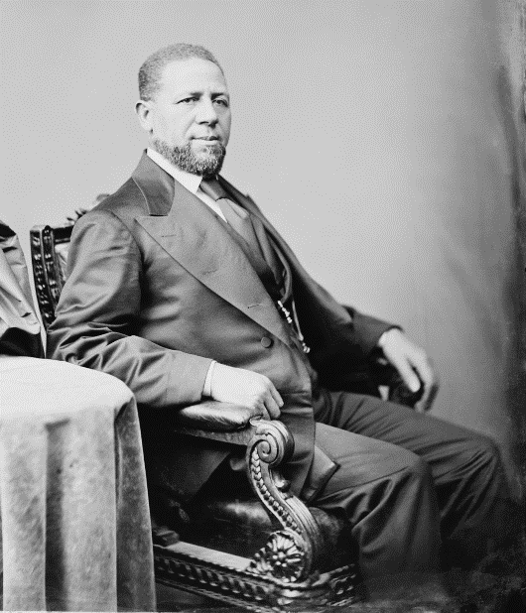
Hiram Rhodes Revels
He was the first African American to serve in the United States Senate. He was also the first African American to serve in the South, which was for Mississippi.
He fought for the Union in the Battle of Vicksburg during the Civil War.

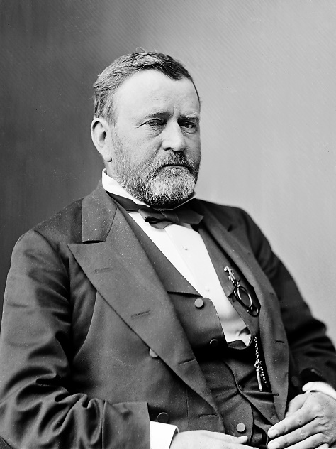
Election of 1868 and 1872
Ulysses S. Grant is elected as the 18th President of the U.S. Grant had no political career before this election, but he was the former commander of the Union Forces during the Civil War and he was very popular. His first term as President was full of corruption and scandals. Many of his party and cabinet were involved in “shady” things.
During his second term, the economy wasn’t doing real well and the U.S. was suffering and economic depression. People in the North were tired of dealing with the South.

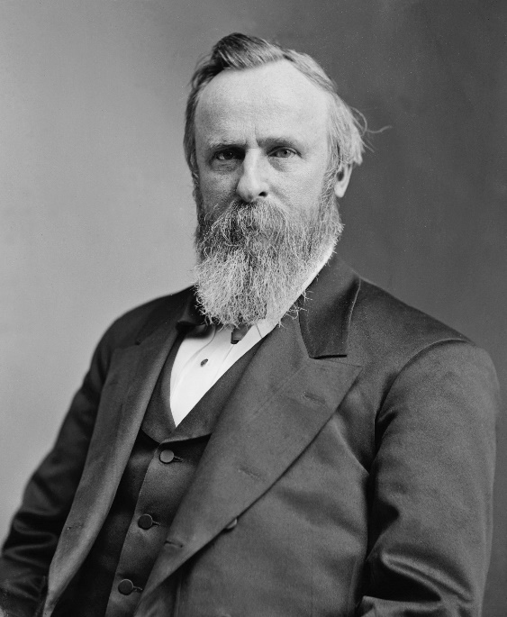
End of Reconstruction and Election of Rutherford B. Hayes
Many southern states were gaining more and more political and social influence throughout the Reconstruction. The KKK was getting more powerful, and the South was simply getting their power back. Rutherford B. Hayes was elected President and he won by compromise after the election needed to be recounted. His presidency marked the end of Reconstruction.

