Notes – Industrialization and Reform Movement

Industry - economic activity involving the processing of raw materials and manufacture of goods in factories
Industrialization - the development of industries in a country or region on a wide scale (Ex: Northern Manufacturing Industries)
Manufacturing - make (something) on a large scale (mass production) using machinery like in factory
Reform - make changes in (something, typically a social, political, or economic institution or practice) in order to improve it
Mill - building fitted with machinery for a manufacturing process
Textile - a type of cloth or woven fabric
Industrial Revolution
As populations in urban (cities) environments grew, the opportunity grew for farmers living in rural (the country) areas to move closer to cities looking for work (jobs).
As new immigrants flooded into the U.S. seeking to better their lives, they needed work and many of the urban areas they lived in created jobs and used the immigrant labor to meet the demand for manufactured goods.
Textile Industry
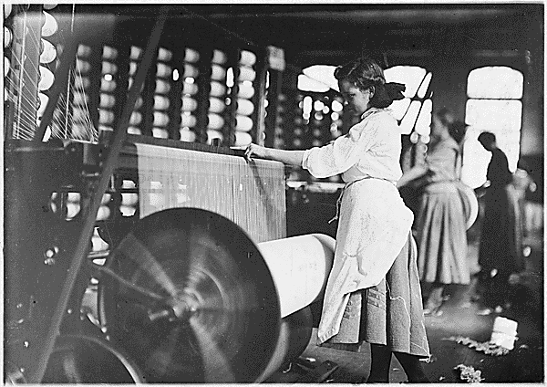
As innovation (inventions and processes) improved, so did the technology in manufacturing. Clothing items (wool, cotton, etc) used to take a very long time to manufacture.
Water was soon found to be able to power the machinery (known as water power) and greatly improved the textile mills.
One of the most famous textile mills in the U.S. was called the Lowell Mills located in Lowell, Massachusetts. The women who worked there were called the Lowell Mills Girls.

Lowell System and Lowell Mills Girls
Again, mills began using water-power to operate the machinery. This made weaving and cloth-making much faster. A man named Francis Cabot Lowell developed different approaches to the textile industry that would change the face of manufacturing industries altogether.

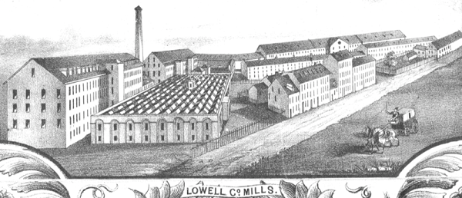
Lowell Mills System
F.C. Lowell would hire unmarried and young women (often 15-25 range) to live in dormitories on factory grounds so that they could be close to work. This would lead to increased manufacturing and a constant stream of labor.
Hard Work at Lowell Mills
The women had to dress a certain way, behave a certain way, and were paid much less than a man would in a similar industry.

Interchangeable Parts
Making muskets (rifles) was very time consuming and required a lot of detail work. The U.S. needed more muskets to prepare for conflicts much faster. Soon, the invention of interchangeable parts was used to mass-produce these guns using the same parts that could be swapped out and used on any rifle.
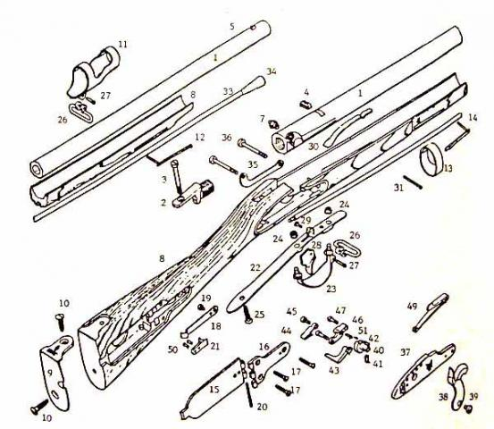
This idea of interchangeable parts in mass-production led to mass production of interchangeable parts for machinery in factories to always keep the factories running, the manufactured goods selling, and the factory owners rich.
Mass-production – making the same product over and over again in large numbers

Changes in Transportation
As new methods of transportation began being invented such as steamboats and canal systems, cities were being connected to ports which boosted industry, which created more jobs.
The inventor of the steamboat was Robert Fulton.
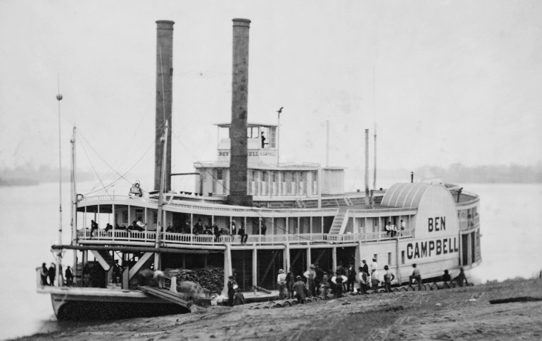
The steamboat was a great invention for trade and commerce as it allowed the ships to travel upriver against the flow of the current of the water.
Gibbons v. Ogden
This case reinforced the right of the federal government to be the only government who had authority to “regulate interstate commerce” (rules for business between states). This cased opened up shipping to many more ships and companies.

Steam Powered Locomotive Travel (Trains)
As the steamships, railroads were also very important for trade and travel throughout the United States. Railroads were being built to connect the north to the south and the east to the west. The Gadsden territory was specifically purchased for $10 million from Mexico after the Mexican Cession for a transcontinental railroad system.
Cities and towns began to pop up along the railways and the Western expansion of the U.S. was all but on it’s way from being complete.
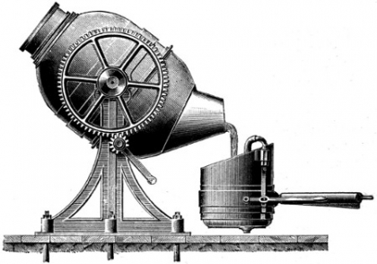
The Bessemer Steel Process
The Bessemer process is the method for making steel by blasting compressed air through molten iron to burn out excess carbon and impurities. The Bessemer process lowered the cost of production steel, leading to steel being widely substituted for cast iron. It was the creation of modern steel.
Telegraph
In 1832, Samuel Morse created the telegraph that could send electronic signals and information through metal wires (much like a telephone now day.)
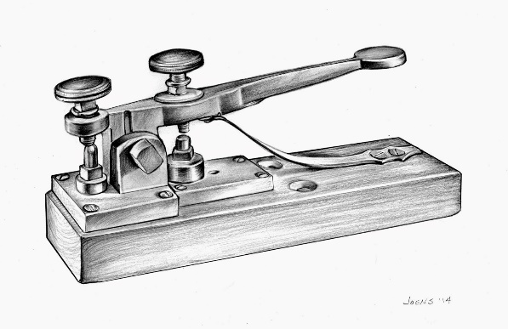
The machine sent electric pulses at one end of a wire and it was transmitted to the other end. This allowed for much faster and accurate communication between distances that were far from each other. Many telegraph lines actually traveled alongside of the railroads.
This system of electric pulses coming from the telegraph machine was known as the Morse Code where different lengths and combinations of electric pulses stood for letters in the alphabet.

Waterpower vs. Steam Factories
During the Age of Industrialization, many factories began using water power to operate their machinery. They essentially had to locate near rivers or waterways to feed the water turbines which would power their machinery.
As coal began its introduction as a fuel source to burn to operate machinery, factories could locate anywhere, not just near waterways. This allowed the North to grow much more rapidly because factories would begin popping up near larger cities which made it easier to find people to work in those factories, especially due to immigrant who were willing to work for lower wages.
Farm Improvements
Farms also began industrializing. These manufacturers began improving their machinery to help their industries:
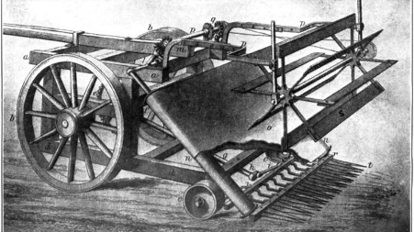
John Deere – created the steel plow using a steel blade instead of traditional iron plows
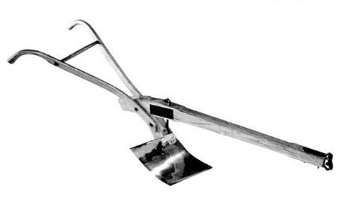
Cyrus McCormick – developed the mechanical reaper, a wheat cutting machine for the large crops of wheat in the Midwest

Home Improvements
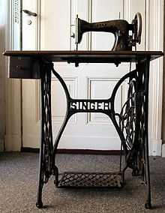
Isaac Singer – developed a sewing machine improvement, which originally came from an idea at the Lowell Mills, where he would sell on credit and provide repair services. This opened up industries in the sewing areas.
South on the Rise
No longer was cash crops just your indigo, rice, and tobacco, now cotton was becoming king.
Eli Whitney’s Cotton Gin
Eli Whitney was an inventor an in 1793 he invented a machine that would revolutionize the south and cotton industry. This was called the cotton gin. It would remove seeds, making cotton picking much faster.
Great Britain needed more cotton for their textile industries and became America’s #1 importer just as America’s textile industry. The need for faster cotton production was real.
This cotton gin was supposed to reduce the number of needed slaves to pick cotton, however, it produced the opposite effect. As the cotton industry became absolute king, more cotton gins were ordered and more slaves bought and sold to work the machines and produce more profit for landowners. This turned much of the south into what is known as the “cotton belt” or the belt of land in the south that was strictly producing cotton as its sole cash-crop
Crop Rotation
The ideas of rotating crops was not thought of automatically. After several years of mass cotton production, the soil was useless. Scientists begin to introduce ideas to farmers to rotate what grows on the land every so often to keep the nutrients in the soil. This led to better soil and better land to produce more crops.
Slavery in the South
The North most mostly a manufacturing society while the South was mostly involved in the plantation system/agricultural business. The major shipping cities of the South and the North lied along the Atlantic coastline and often, raw materials from the South would be shipped to the North via new modes of transportation to include railroads, rivers/steamboats and the like.
Slave families in the South were often split up, slave codes (better food and treatment or harsh harsh punishments) were used to encourage certain behaviors by the slaves.
Free vs. Slave African Americans
Most African Americans living in the South were enslaved people. However, due to circumstances or sheer luck of time, some were free and worked as paid labor or had special trades (jobs) they performed.
Even though some African Americans were free:
- No voting
- No traveling wherever you pleased
- Could not hold certain jobs
- No inter-mixing with whites

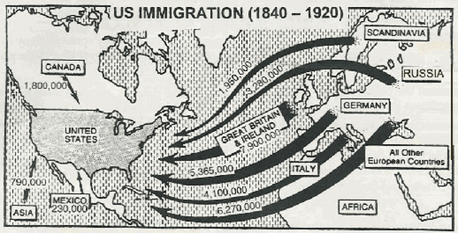
Immigrants in America
Famine – extreme scarcity, lack of a certain resource like food or water
Many arrived in the 1800s to better their lives. (Think if PERS, why do people move?) Many arrived from Europe to include Ireland (the Irish) and Germany escaping economic or political issues.
Irish and the Potato Famine
Ireland depended on heavy potato farming. During the 1840s, a disease caused potatoes to spoil and rot and therefore left a lot of Irish out of work, they starved, and many died of disease.
Many poor Irish farmers and immigrants poured in to the U.S. settling in eastern cities in New York, New Jersey, Massachusetts, and Pennsylvania. Many of the immigrants filled the low paying jobs building railroads, canals, in the factories, or other types of manual labor.
Anti-Immigration on the Rise
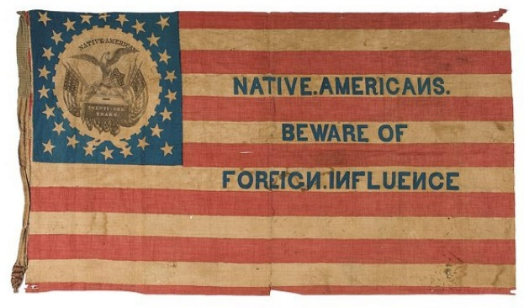
Many immigrants moved to the East Coast urban (cities) areas. Many native-born Americans feared their social status and jobs were going to be taken away by the cheap labor of the immigrants.
Nativists are people who feared immigration. Many Protestants (Christian but not Catholic) did not like the Catholic immigrants moving into the U.S.
This Anti-immigration attracted people to create a political party (like the Republicans and Democrats) called the Know-Nothing Party that supported making it hard for immigrants to become citizens or hold elected office.
Cities Began to Grow
As more immigrants flooded the shores of the U.S. and into cities in the Northeast and Midwest, the cities began to rapidly expand. People began to leave their rural lifestyles (out in the country on the farm) and into the urban areas (cities) to find or be closer to work as more and more job opportunities presented themselves in the cities.
Transcendentalism
A term founded by New England philosophers, writers, and spiritual leaders of the time that believed that people could rise above their situations (to transcend) or troubles in to better places or a better life.
Transcendentalists believed people should be more self-sufficient, depending on themselves than others or outsiders.
Famous Transcendentalists and their works are as follows:
- Ralph Waldo Emerson – wrote an essay called Self-Reliance and a book called Nature

- Henry David Thoreau – known for his essay called Civil Disobedience, was a tax protestor
- Nathanial Hawthorne – known for his book The Scarlett Letter
- Edgar Allen Poe – poet known for his work called “The Raven”
- Emily Dickinson
- Henry Wadsworth Longfellow – famous poem of “Midnight Ride of Paul Revere”
- Walt Whitman – wrote a poem called Leaves of Grass
Second Great Awakening
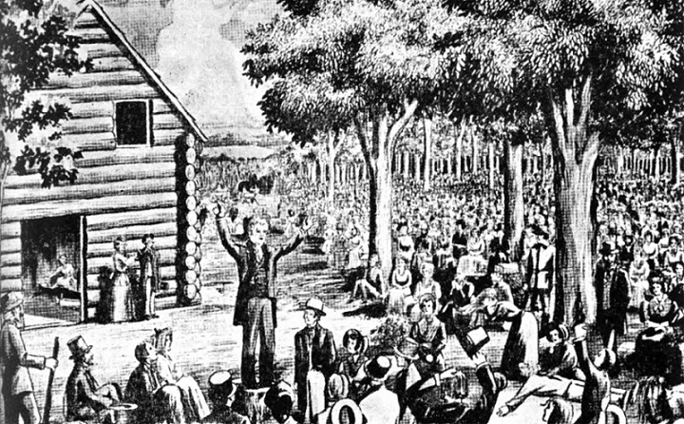
Like the first, this was a time in America where one would see many religious revivals, new found Christianism spreading through the country.
Many religious revivals (large gatherings where preachers would preach) happened all over. They talked about how people had gone too far away from God and needed to come back and trust and become a better person. This led to the spread of the African Methodist Episcopal Church

Temperance Movement
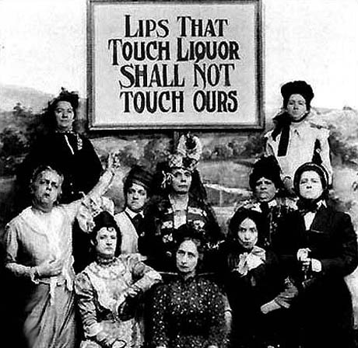
Many people believed alcohol was a root problem of evil in America. They believed alcohol was spreading violence, crime, drunkenness, and family violence (domestic violence.)
These reformers believed by banning hard-liquor, husbands would treat their wives better and quit using money or alcohol, and people overall would better their lives.
Many women of the middle-class would begin to join in the Temperance Movement along with the women’s rights movements.

Prison Reform and Mentally-Sick
Dorothea Dix led a movement for changes in prisons. She believed that we should not just lock away people or people who were mentally ill and keep them confined in dark cells with regular criminals, sometimes no food and little clothing. She talked about them often being chained to walls.
Education Reform
Horace Mann was the “Father of Public Education.” He called for reform in public education and wanted all children regardless of background to have a common education. He began the first teacher training programs and helped to raise teachers’ salaries.

Abolition Movement
Abolition means to completely get rid of something…like slavery. Many in northern America wanted to end slavery for good. Several people were very big in the abolitionist movement such as the follow:
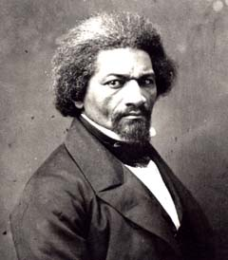
- William Lloyd Garrison – founded the American Anti-Slavery Society
- Frederick Douglass – former slave who was freed and became a huge figure in abolition and some women’s rights

- Sojourner Truth – former slave who believed God gave her a calling to travel and preach about slavery and women’s rights
- Harriet Tubman – conductor (she helped lead) the “underground railroad” to help escaped slaves free the South and into the free North
Underground Railroad
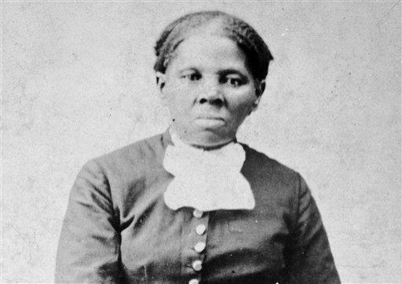
Harriet Tubman was the conductor for the “underground railroad.” It was series of pathways with hiding spots called stations to allow the movement of escaped slaves undetected until they arrived in the free northern states

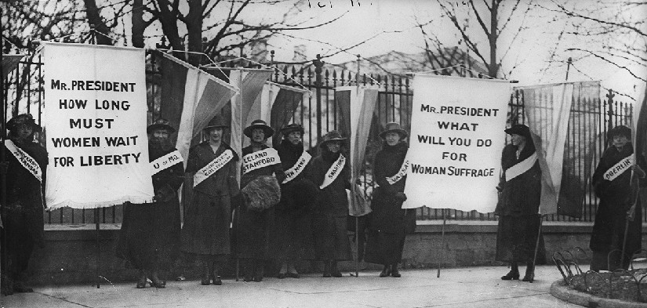
Women’s Rights and Suffrage Movements
Women throughout the country (mainly the North) wanted some form of equal treatment and rights. Many abolitionists also joined the women’s rights movement. Many women believed they were being treated as second-class citizens. Leading members of the movement were:
- Elizabeth Cady Stanton
- Lucretia Mott
- Susan B. Anthony – leader for women’s suffrage
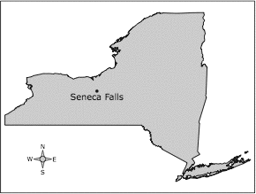
Seneca Falls Convention
As a result of the increased women’s rights movement, and the need for reform in the U.S., Elizabeth Cady Stanton and Lucretia Mott organized the first women’s rights convention in the U.S. in 1848. It was located in Seneca Falls, NY
- Declaration of Sentiments – much like the Declaration of Independence was, this document was charges against men (instead of King George III) and outlined their beliefs about women’s rights

