Notes – Heading Towards War
Mexican Cession and Slavery Issues
Do we allow slavery in this new land or not? Polk wanted to extend the Missouri Compromise line all the way to the Pacific, essentially dividing the North and South into Free and Slave.
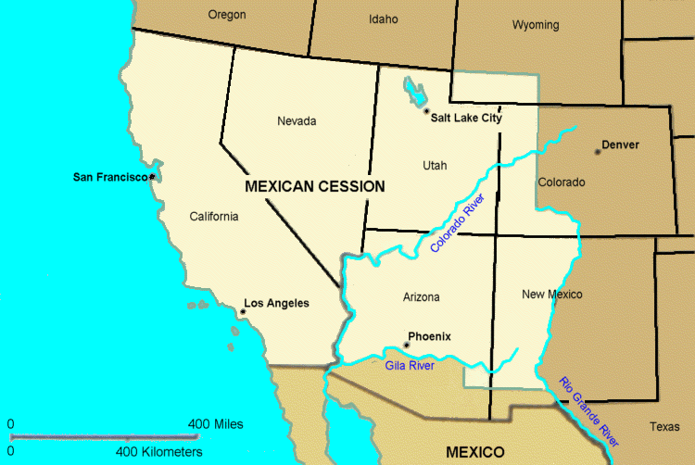
Wilmot Proviso
Representative David Wilmot wrote the Wilmot Proviso which stated that “no slavery should be allowed in any party of the Mexican Cession territory (paraphrased).”
Even though the proviso did not pass in both the Senate and House of Representatives it helped lead to more sectionalism.
Northerners who believed in anti-slavery (abolition) created a new political party called the Free-Soil Party in support of the Wilmot Proviso.
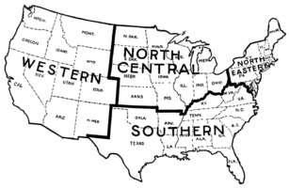
Sectionalism Leading to Conflict
Northerners had their own “section” or interests, Southerners had their own “section” or interests and people out west either took the side of the Northerners or Southerners or had their own interests as well.
Sectionalism could cause conflict because each region that forms its own smaller section will start behaving and doing things that only furthers their own section and not the greater good of the whole country.
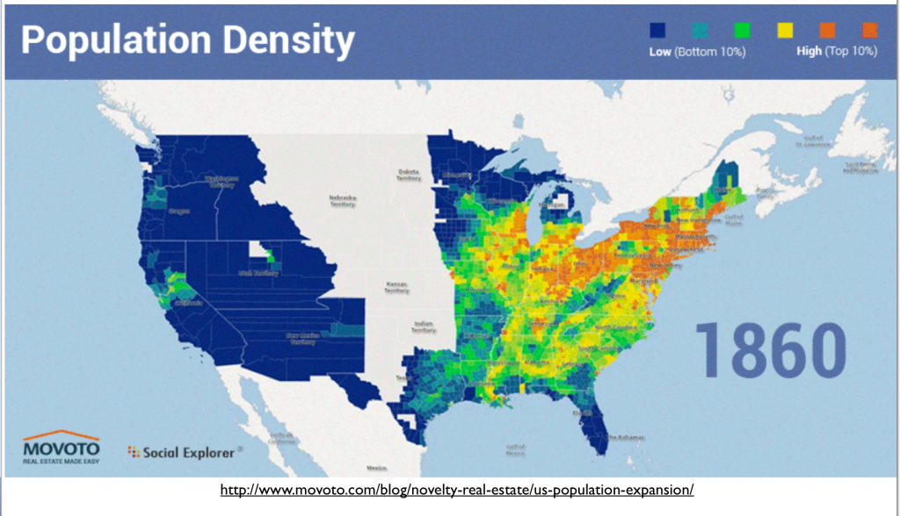
California’s Population Explodes
As California grows rapidly due to expansion of the railroad and the Gold Rush, it wants to enter the Union as the next state, BUT, as a free state. Many in the Southern states opposed this idea as it would mess up the balance of power in Congress between free states and slave states.

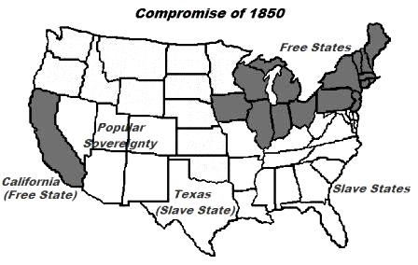
Compromise of 1850
A compromise to allow California to enter as a free state was reached. The following terms were agreed upon.
- California comes in free-state
- The rest of the Mexican Cession (Utah and New Mexico) would use popular sovereignty to decide the free or slave issue
- Texas gives up some land to pay off their debts owed to the U.S.
- No more slave trade (active buying and selling of slaves) allowed in Washington, D.C.
- More effective Fugitive Slave Law put in place
Fugitive Slave Act
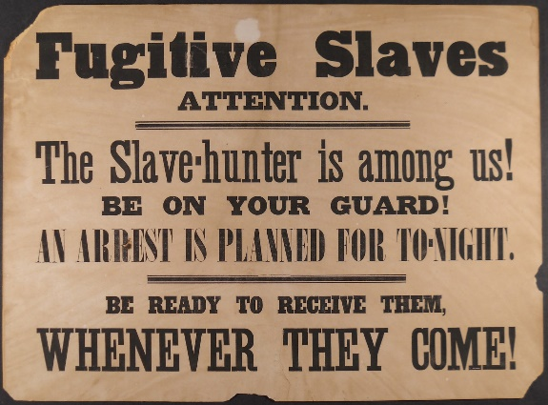
Made it illegal to help a runaway slave, and any official who caught them in the free-state areas could arrest them and send them back to their slave states. Since African Americans had no rights, they couldn’t speak on behalf of themselves and they couldn’t receive help for fear of jail for the helper.
Uncle Tom’s Cabin
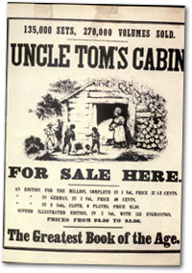
Written by Harriet Stowe tells the story of the horrors of slavery as it existed. Although fictional, the story encouraged many Northerners to join the abolitionist movement and it angered many in the South. This story even made it as far as Great Britain and Queen Victoria. England had already earlier abolished slavery. It sold more than 2 million copies in a decade.

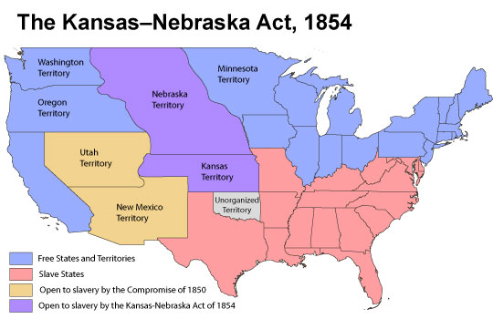
Kansas-Nebraska Act
Introduced by Stephan Douglas in 1854, it divided up the remaining land of the Louisiana Purchase into the Kansas Territory and the Nebraska Territory. The people in each territory would then choose (vote…popular sovereignty) whether or not to be a free territory or slave territory.
Many Northerners hated this new law.

Kansas
Anti-slavery and pro-slavery groups rushed into Kansas. An election to decide if Kansas was to become free or slave came in 1855. Many out-of-staters crossed the border and voted giving the pro-slavery crowd an easy win.
The anti-slavery crowd called for a new election. Two new governments (one free and one slave) began to form in different parts of the territory. The U.S. President Franklin Pierce only recognized the pro-slavery government though.
In 1856 a committee from Congress decided the first election was unfair. Pro-slavery groups rode into Lawrence, Kansas to arrest traitors of the government who were in the anti-slavery group. When they got there, the anti-slavery group was gone. The pro-slavery riders burned and looted the town during the fighting.
John Brown – An Abolitionist
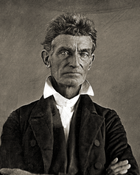
John Brown moved to Kansas in 1855. In 1856, he and his anti-slavery men killed 5 pro-slavery men with swords and he said God had made it happen.
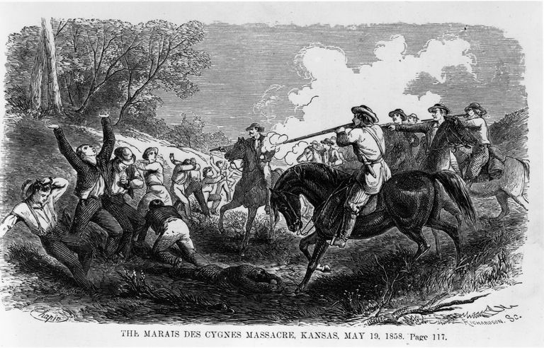
Bleeding Kansas
Because of tensions and John Brown’s actions, all out civil war broke out. Approximately 200 died in the fighting which became news around the country.

James Buchanan Becomes President
Members of multiple parties against the spread of slavery created the Republican Party. The old Democratic Party stayed the same. James Buchanan who had been James K. Polk’s Secretary of State had won the election.
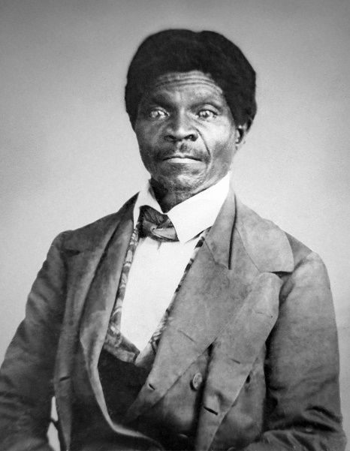
Dred Scott vs. Sanford
Dred Scott a former runaway slave moved to Illinois and Wisconsin after living in Missouri with his master. When they returned to Missouri, Scott’s master died. Dred Scott then sued for his freedom even though he was in Missouri because he claimed he was free in Illinois and Wisconsin.
Chief Justice of the U.S. Supreme Court Roger Taney eventually issued the opinion of the court in the Dred Scott case that made it all the way to the highest court. His decision was the following:
- African Americans and former slaves have no citizenship rights and therefore no rights to sue in court
- Slaves are property, so a master can take a slave anywhere they want
- The Missouri Compromise which divided slave and free states was unconstitutional
Lincoln-Douglas Debates
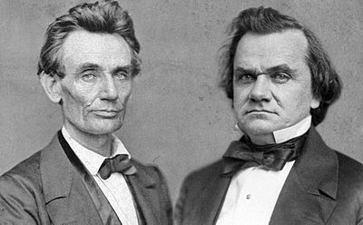
Illinois U.S. Senate Republican nominee Abraham Lincoln ran against Democrat Stephen Douglas, also from Illinois. Their debate was famous with Lincoln calling for African Americans to have all the natural rights listed in the Declaration of Independence although not outright equality. Lincoln wanted to limit the spread of slavery in the west.
Stephen Douglas said that there COULD NOT be a half free and half slave-holding country. It had to be one or the other. Douglas warned that trying to abolish slavery would lead to a failure of the U.S. and outright war. Democrats were for popular sovereignty when deciding the slavery question. Douglas won the Senate election.
Raid on Harper’s Ferry, Virginia
John Brown (white abolitionist) who was involved in the Bleeding Kansas events decided to start a slave rebellion and gathered a small force (including his sons) to raid a U.S. weapons arsenal at Harper’s Ferry. His goal was to arm local slaves. He took men to Harper’s Ferry arsenal but suffered heavy losses to his small force.
The next day, Colonel in the U.S. Army at the time Robert E. Lee killed and captured the rest of his men including John Brown. He was sentenced for treason and ordered to be hung.
Election of 1860 – The Lincoln Election
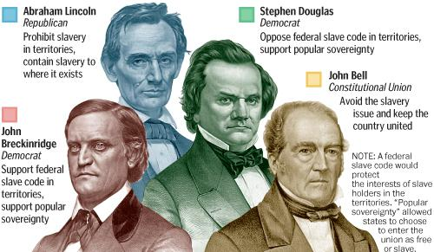
Stephen Douglas was the candidate for the Northern Democrats. John C. Breckenridge was the candidate for the Southern Democrats (also Vice-President at the time). Abraham Lincoln was the candidate for the Republican Party, and then there were several other candidates who stood little chance to win.
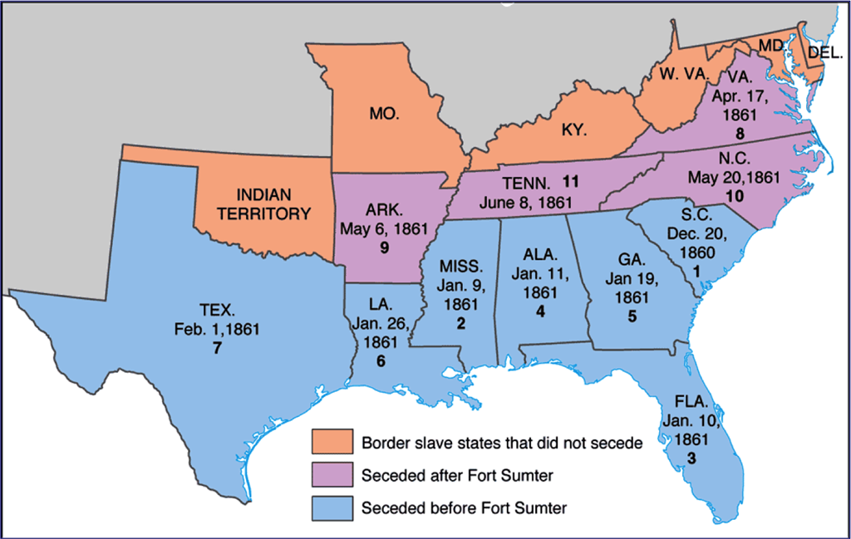
Lincoln was feared by many Southerners as a person who would try to take away their rights to own slaves (abolish). Many Southern states talked about secession (to leave the U.S.) if Lincoln was elected. Lincoln easily won the electoral-college and was elected as the 16th U.S. President.
Secession in the South
During his inaugural address as President, Lincoln swore his goal was not to get rid of Southern slaves, just keep the Union together and not expand upon slavery any more than it already had, which would over time end it. This did not sit well with some in the South.
After the Election
South Carolina was the first state to call for a convention to draw up documents to secede (secession). Secessionists believed they had the right to secede the Union because they also voluntarily formed the U.S. in the first place.
Lincoln completely disagreed and believed that no state had the right to just leave the Union when it wanted and to do so would be the same as revolution.
Lincoln believed the U.S. had to choose either “all” slave or “all free,” there could be no compromise or in between.
The Confederate States of America (CSA)
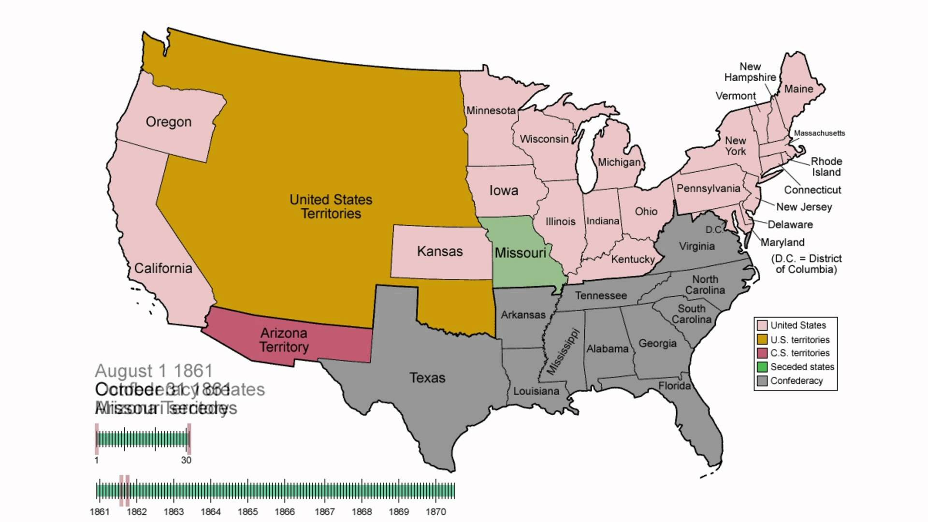
South Carolina created papers to secede the Union and it passed in their state legislature on December 20, 1860. Mississippi, Florida, Alabama, Georgia, Louisiana, and Texas followed the same path of secession. We called them by the nickname the South or the Confederacy.
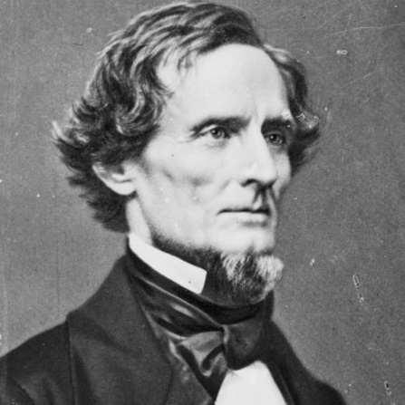
The CSA wrote their own Constitution and chose President Jefferson Davis, a congressman from Mississippi to be their leader. Their government was set up the same as the U.S. government, yet they claimed to be independent.
Lincoln’s Reaction to Secession
Lincoln again believed the states in the South couldn’t just leave on their own. He did not recognize the secession. He also said the federal government (the U.S.) would keep all U.S. property located in the South. He said he did not want to provoke war with Southern states.

